Wolfgang Puck’s, Grace Skalski’s and Angie Barbour’s
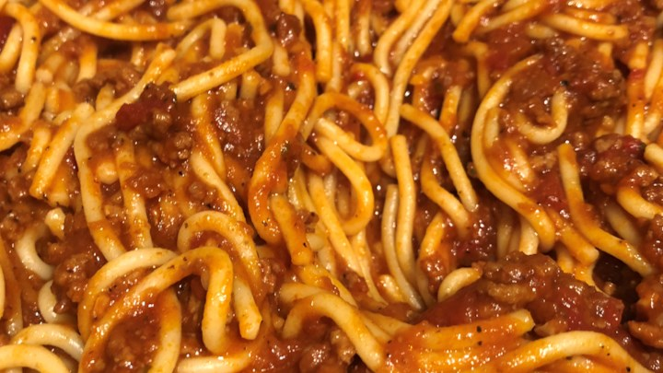
Spaghetti Sauce
Ingredients
1 lb Italian sausage
2 small onions, minced
10 cloves of garlic, minced
(2) 14 oz cans crushed tomatoes
(1) 14 oz can tomato sauce
1 small can tomato paste
2-3 cups of chicken broth
1 tsp sugar
¼ cup julienned fresh basil
Directions
- Cook Italian sausage and onion in frying pan with lid over medium-high heat, stirring often.
- Add in garlic and cook about one minute.
- Stir in the crushed tomatoes, tomato sauce, and paste.
- Add sugar. Stir and cook three minutes.
- Stir in broth and heat to a simmer. Cook until thick, 20-30 minutes.

Notes
Substitute beef broth for chicken broth if using ground beef.

